yazı tipi, grafik, grafik tasarım, logo içeren bir resim

Açıklama otomatik olarak oluşturuldu**İZMİR KATİP ÇELEBİ UNIVERSITY FACULTY OF ENGINEERING AND ARCHITECTURE DEPARTMENT OF MECHATRONICS ENGINEERING**

**Name Surname: Student ID:**

Merve Ergenç 200412030

Mert Sürekci 200412067

Enes Fide 200412009

Melik Nuri Erdem 200412027

**Hydraulic System for an Automatic Bridge Project**

**1. Objectives**

Design and control a hydraulic system that operates an automated bridge. The system aims to demonstrate efficient lifting and lowering mechanisms using hydraulic components while incorporating control strategies for automation.

**2. Bridge Specifications**

* **Material:** Steel
* **Length (L):** 20 meters (each side, total span = 40 meters)
* **Width (W):** 8 meters
* **Thickness (t):** 0.4 meters
* **Density of Steel (ρ):** 7850 kg/m³

**Weight Calculation**

1. Each bridge side dimensions:
   * Length (L): 20 meters
   * Width (W): 8 meters
   * Thickness (t): 0.4 meters
2. Volume of one side of the bridge: V=L×W×t=20×8×0.4=64 m³
3. Weight of one side: W=V×ρ×g=64×7850×9.81=4,924,032 N
4. Total weight for both sides: W total=2×4,924,032=9,848,064 N
5. **Component Selection**

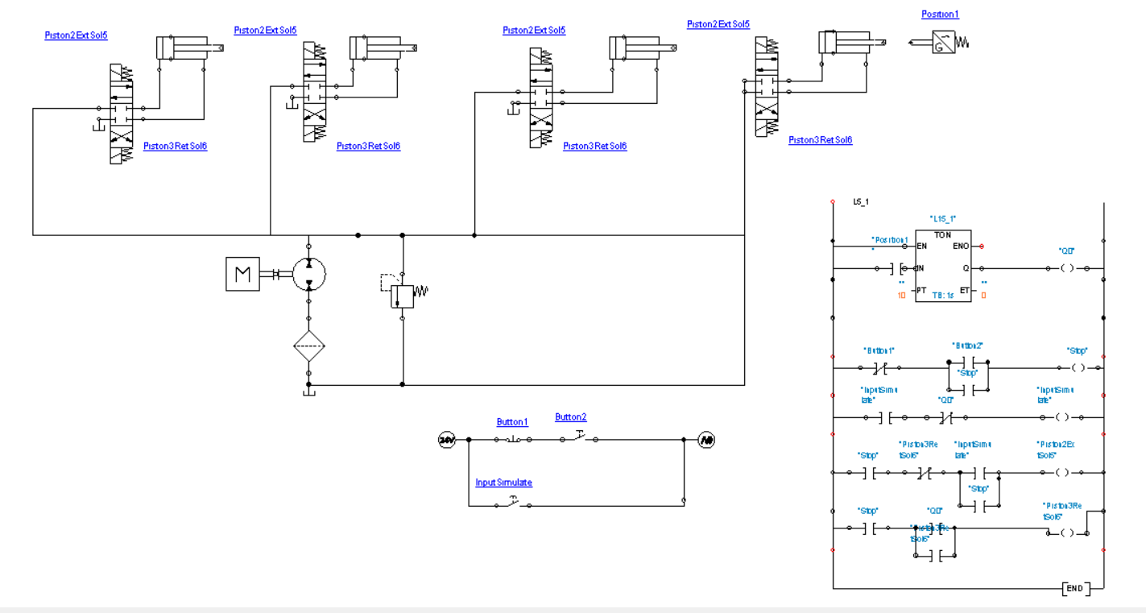

*Figure 1: Hydraulic System*

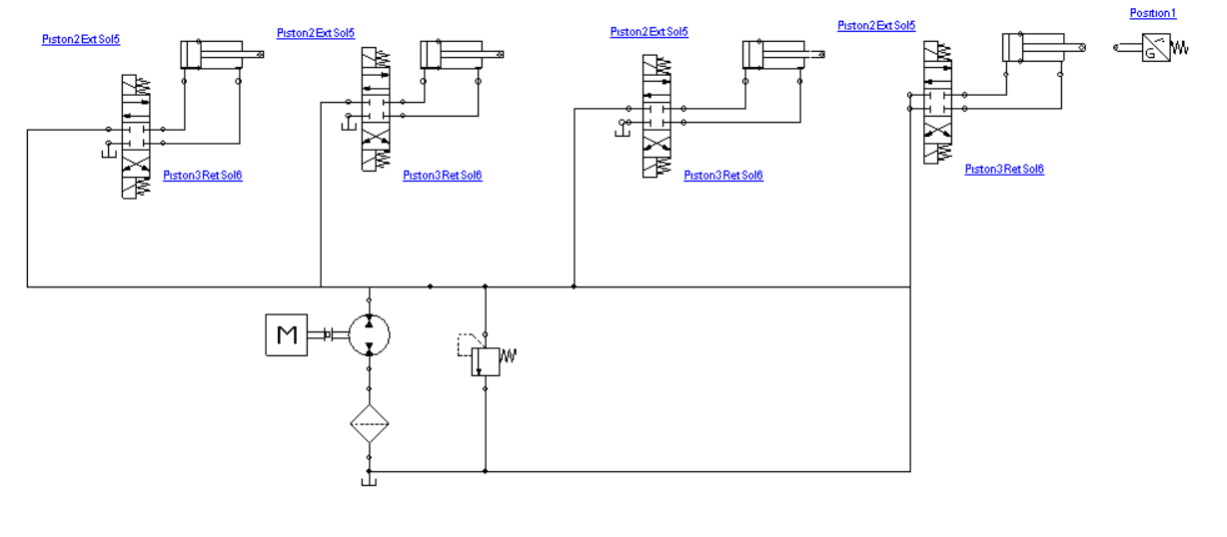

*Figure 2: Hydraulic Circuit*

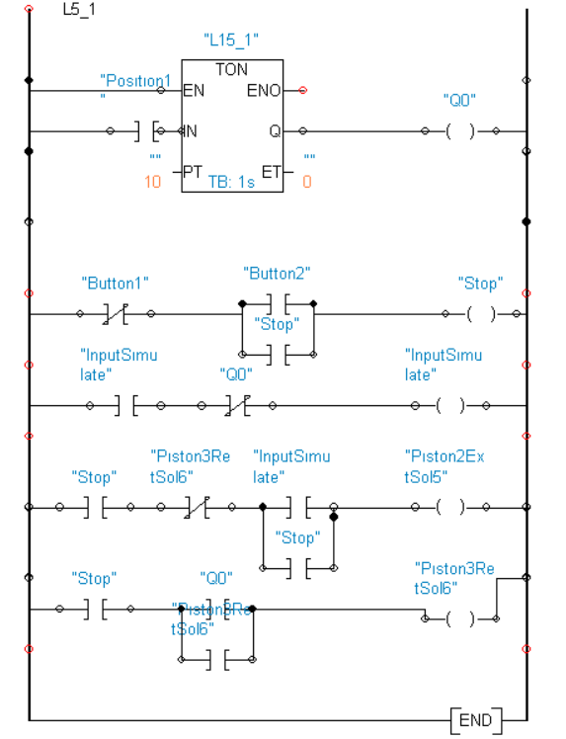

*Figure 3: Ladder System*

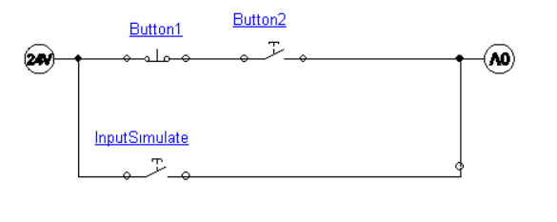

*Figure 4: Electrical Circuit*

(Input Simulate) is added to the circuit to simulate only the ship passage data

**Hydraulic Cylinder**

* **Bore Diameter:** 485 mm
* **Stroke Length:** 2 m
* **Pressure Rating:** 250 bar (to ensure safety margin)

**Hydraulic Pump**

* **Flow Rate:** 36.94 L/min per cylinder (total = 147.76 L/min for 4 cylinders)
* **Pressure Rating:** 250 bar
* **Power Rating:** 3000 kW

**Reservoir**

* Capacity: At least 1.5 times the total fluid volume (approx. 300 L)

**Valves**

* Directional control valves (4/3 way) with pressure rating of 250 bar.

**4. Control System Design and Logic**

The control system manages the automatic lifting and lowering of the bridge and ensures safety and efficiency. It includes:

**Control Logic**

* + 1. **Initial State:**
       - Bridge is in the closed position.
       - All valves are in the neutral position.
    2. **Lifting Sequence:**
       - Activation of the start button sends a signal to the controller.
       - The controller energizes the directional control valves to extend the hydraulic cylinders.
       - Position sensors monitor the cylinder stroke to ensure full extension.
    3. **Lowering Sequence:**
       - Activation of the lower button sends a signal to the controller.
       - The controller reverses the valve positions, retracting the hydraulic cylinders.
       - Position sensors monitor the retraction to ensure proper closure.

**Sensor and Feedback**

* + 1. **Position Sensors:** Detect cylinder extension and retraction.

**Controller Design**

* + 1. **Ladder Diagram**
       - Ladder logic programming is used to control the sequence of operations.
       - Inputs: Start, lower buttons, timer, position sensors.
       - Outputs: Solenoid signals for directional control valves.

**5. Bridge Inventor Design**

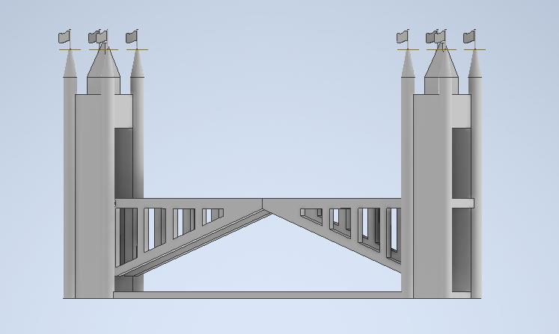

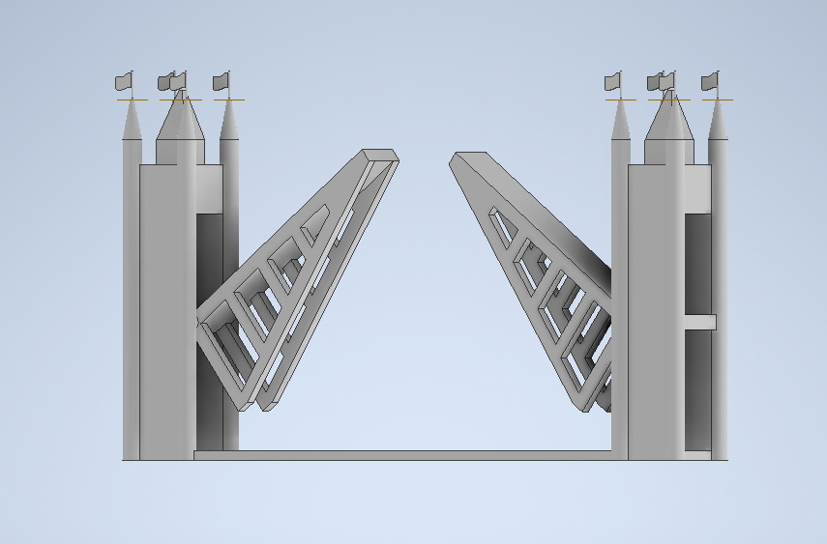

The bridge was modeled in a Inventor to visualize the dimensions and mechanical structure. The drawing includes:

* The two bridge sides.
* Hydraulic cylinder mounting positions.
* Pivot points for the double-opening mechanism.

**6. Hydraulic Circuit Simulation**

The hydraulic system was designed and simulated in Automation Studio. The circuit includes:

* **Hydraulic Pump:** Provides pressurized fluid to the system.
* **Directional Control Valves:** Controls the flow direction to the cylinders.
* **Hydraulic Cylinders:** Operate the lifting mechanism.
* **Reservoir:** Stores hydraulic fluid.

**Simulation Results**

* The system successfully lifted each side of the bridge within 10 seconds.
* The flow rate and pressure were within the specified limits.
* The safety factor ensured reliability under load conditions.

**7. Conclusion**

The proposed hydraulic system, consisting of four hydraulic cylinders, a pump, control valves, and a Ladder diagram, meets the requirements for lifting the double-opening bridge. The Inventor design, hydraulic simulation, and control logic validate the design's feasibility, ensuring adequate power, force, and reliability for safe operation.